Bash video 2 task
1.Create a bash script to check if a directory is available or not.
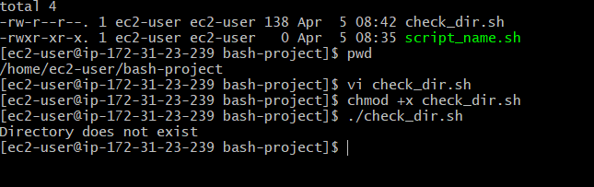

2. Create a bash script to create multiple files.
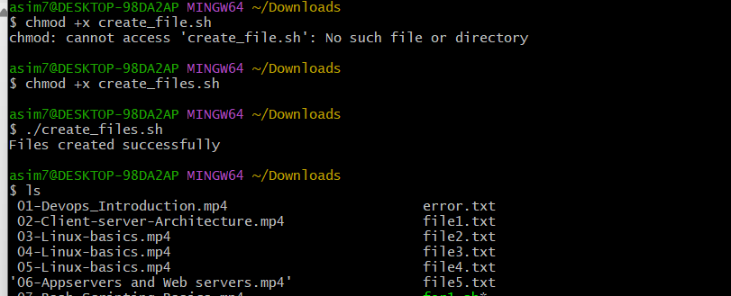

3. Create a bash script to take a backup of a directory.

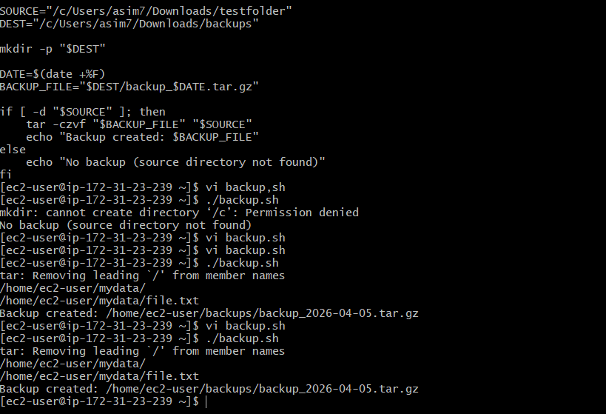

4) Create a bash script to install Nginx on an EC2 server.

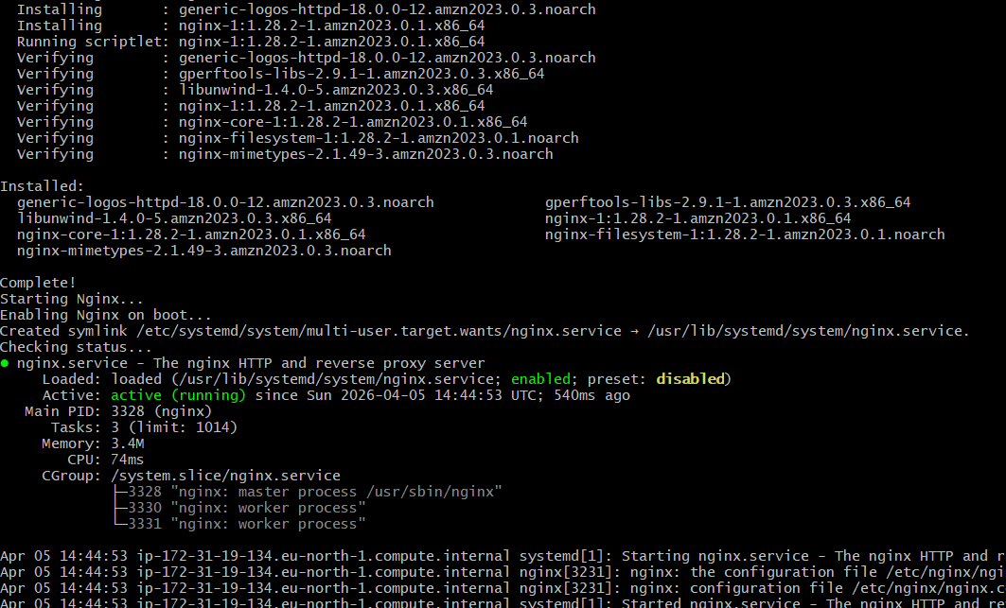

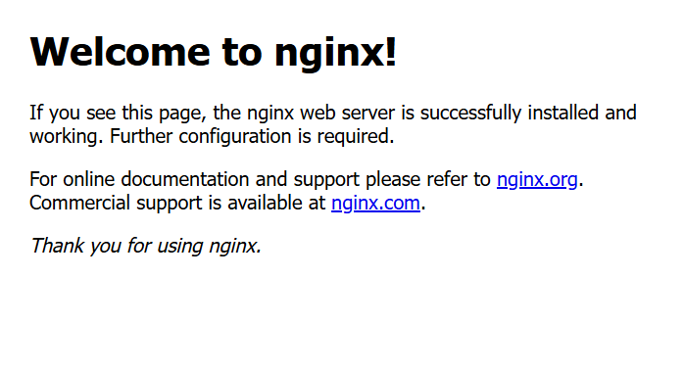

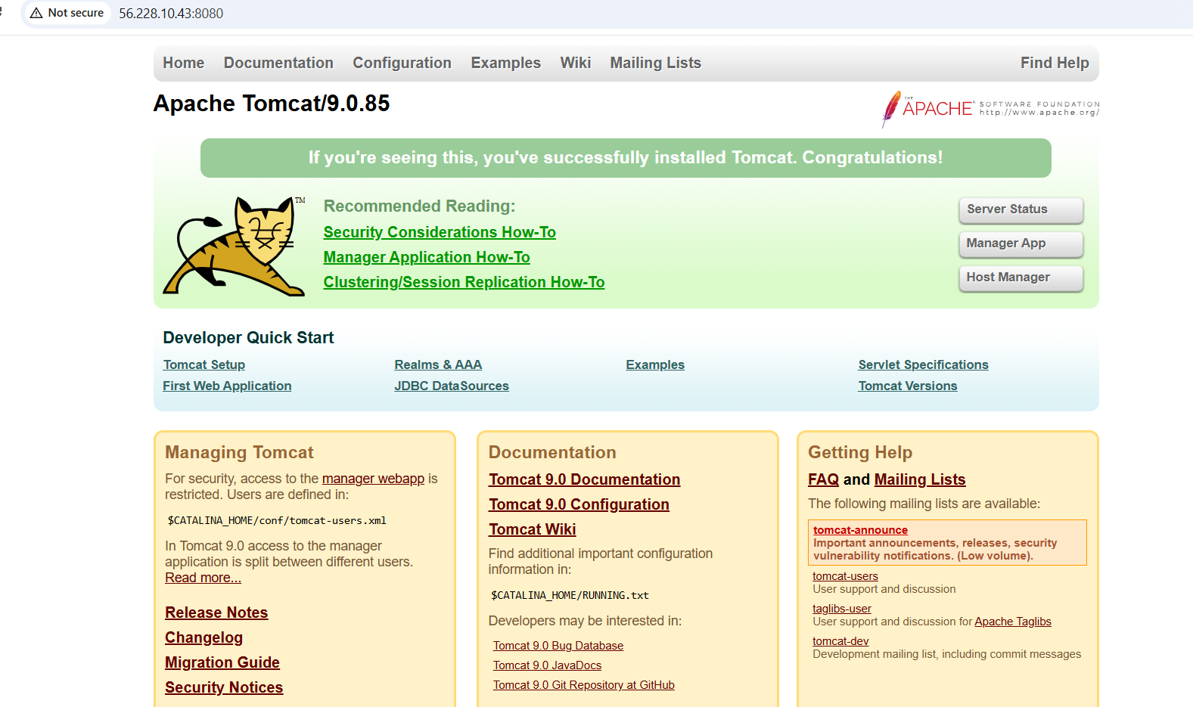

Create a bash script to install Apache Tomcat on an EC2 server.

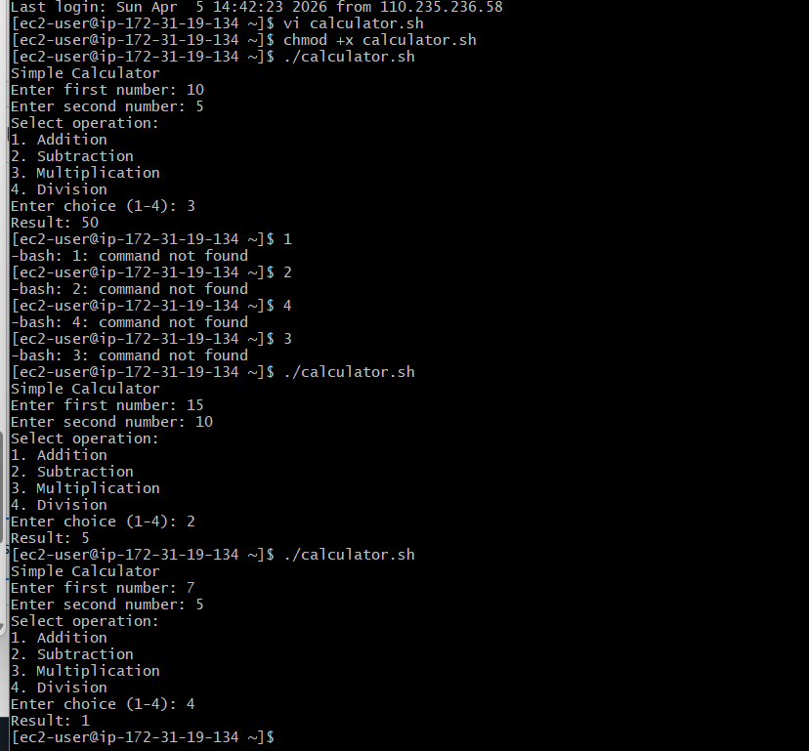

Create a bash script for a calculator.

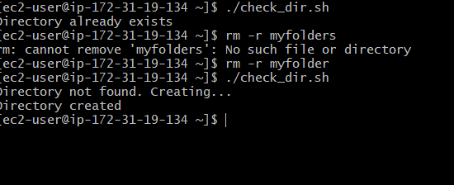

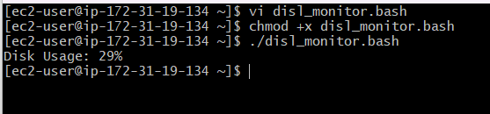

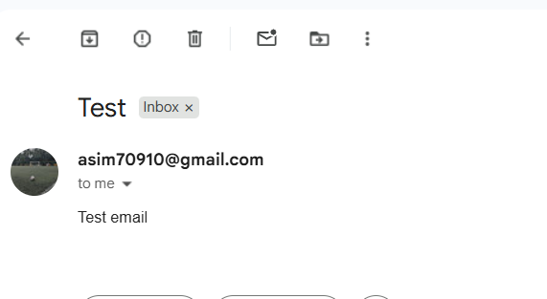

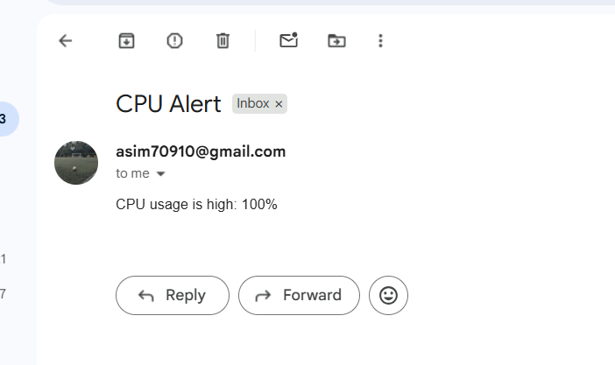

Bash script to monitor cpu and if it is more than 80% then send email notification.
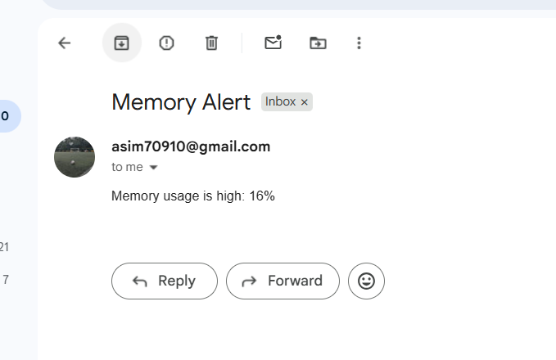
Bash script to monitor memory and if it is more than 80% then send email notification.

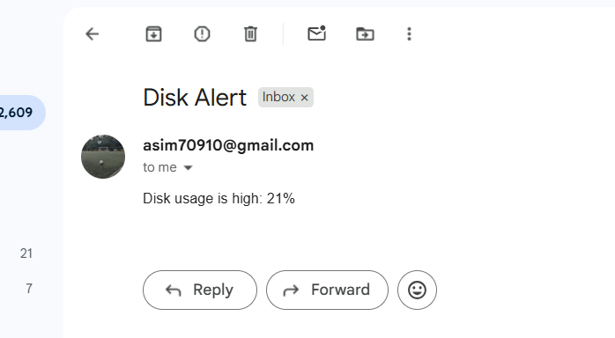

Bash script to monitor disk space and if it is more than 80% then send email notification.

..…………………….| Done |……………………….

